[](https://www.google.ca/url?sa=i&url=https%3A%2F%2Fwww.holidaypng.com%2Fpng%2Ftransparent-grass-meadow-for-easter-spring-grass-ewy3uu%2F&psig=AOvVaw2rBwKOLYtCevjreyRkPNXD&ust=1586290023669000&source=images&cd=vfe&ved=0CAIQjRxqFwoTCNjCrJvN1OgCFQAAAAAdAAAAABAE)[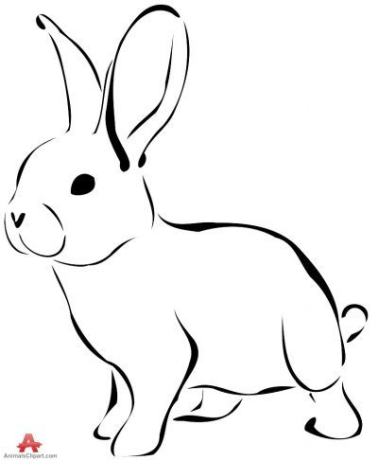](https://www.google.ca/url?sa=i&url=https%3A%2F%2Fwww.pinterest.com%2Fpin%2F38280665567826676%2F&psig=AOvVaw1M7LV_xOjYUerMABpI3VtX&ust=1586288853422000&source=images&cd=vfe&ved=0CAIQjRxqFwoTCMjIwe3I1OgCFQAAAAAdAAAAABAF) **April**  NEWSLETTER **2020**

***April Foolishness***

A good read by Theresa Bateman is a children’s book called “April Foolishness.” In the story, Grandpa the farmer is busy making his breakfast when suddenly his grandchildren rush into the kitchen to tell him the cows are out. He smiles and keeps making breakfast knowing it is April Fools Day. Soon reports of the chickens loose, the pigs escaped, and pretty much everything imaginable flood the kitchen as Grandpa calmly makes his breakfast. Grandma finally asks him if he’s going to deal with the mayhem outside to which he replies, “it’s April fools day.” Crafty Grandma tells him much to his sorrow that “April Fool’s Day is not till tomorrow”—he rushes out frantically as she sits down to enjoy his freshly made breakfast. I love this story as it captures the mischievous spirit enjoyed each April 1st. Look it up—it will give you a chuckle!

We wish that we could report the world situation with COVID-19 was just some “April Foolishness” but it seems we must walk through what our Chief Medical Officer Dr. Deena Hinshaw reports as our “new normal” for the foreseeable future. Wise words many are all too familiar with state “this too shall pass;” and we pause to realize the statement holds true in both the bad times as well as the good. Nothing lasts forever (though winter is making a great effort this year) and we hope you are staying safe while adjusting to the changes found literally everywhere. We hope you’ve found some bright spots as you continue to wear “Snowpants In April” (another wonderful children’s book by local author Tobi Duckering). We wish you and your family a wonderful Easter and all that it means!

[](https://www.google.ca/url?sa=i&url=https%3A%2F%2Fhealix.com%2Fsharing-knowledge-and-news%2Fcovid-19-advice%2F&psig=AOvVaw2qIlA5_lKBKQEiGHRkgG_s&ust=1586291601144000&source=images&cd=vfe&ved=0CAIQjRxqFwoTCOCBuoLT1OgCFQAAAAAdAAAAABAH)***COVID-19: Changes at the Clinic***

While animal care remains our purpose and priority, we have taken measures to protect human safety both for clients and staff. COVID-19 is not a risk to animals, though animals may have the virus on their external surfaces from contact with infected people. With the provincial recommendations in mind we have implemented the following measures:

* We are open regular hours for business and maintain 24/7 Emergency Service; we are screening clients for specific risk factors such as recent travel or symptoms of illness
* Enhanced sanitation for human safety above our regular practices and between EVERY client
* Limited attendance in clinic—vehicles or trailers arriving must call the clinic per posted instructions and receive instruction from staff regarding their appointment or product needs
* Physical distancing in place for protection of human health and safety; personal protective equipment and handwashing available as necessary
* Telemedicine available when needed and extensions for prescriptions when necessary
* Farm calls as usual with physical distancing, handwashing, and other measures as necessary
* Production Animal Medicine (farm animals) has been maintained as an essential service and all products/services remain in place
* Companion Animal Medicine (pets) are restricted to essential medical services in line with public health recommendations and guidance from our provincial and national veterinary medical associations—most services unaffected with exception of elective procedures
* Surgical supplies—at this time we are working to prioritize our surgical supplies by limiting non-essential surgery; most supplies are expected to be available towards June and July

Thank you for your understanding, patience, and willingness to work with us to keep all our clients, staff, and critters safe!

***Coccidiosis: A Pain in the Ass!***

Blood in the manure can mean a couple of things but in calves three weeks to six months of age it leaves high suspicion for coccidiosis, a parasitic infection picked up from manure. These snowy spring conditions can be particularly challenging. Affected calves may have diarrhea of varying severity and often blood is seen with this. Calves with clinical Coccidiosis often strain repeatedly due to irritation of the lower bowel and rectum. Dehydration, depression, loss of appetite, weight loss, and death can occur with this infection. Treatment needs to be early and aggressive—more on that in a bit. Nervous coccidiosis can occur which is a complication of the disease, does not respond well to treatment and includes symptoms such as muscle tremors, exaggerated gait, seizures, or other neurological signs.

Coccidiosis is a silent problem as well, causing subclinical infections in calves, meaning infection and shedding without showing symptoms of the disease causing lost production. This means calves in this age group may be shedding the infective oocysts leading to accumulation in the environment. Calves with light infections often show no symptoms but nevertheless have affected growth and health through impaired intestinal function and feed conversion and thus are less thrifty. When environmental load gets too great in an area, severe coccidiosis can start to develop especially in new calves placed in the area. If you have calves sick with coccidiosis, chances are high that you have more calves infected not showing symptoms as well! This has significant impact on production and warrants attention.

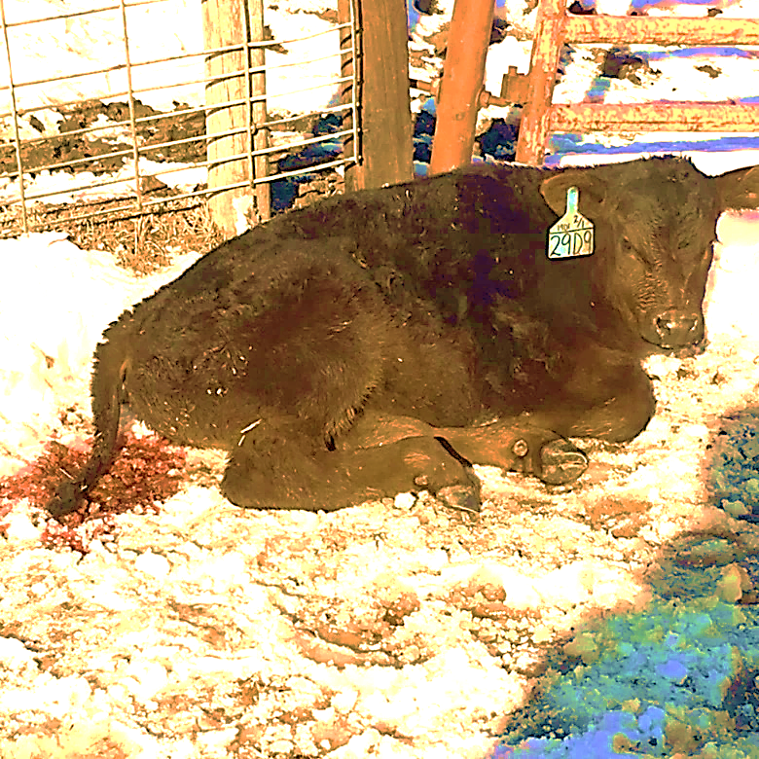Symptomatic calves that recover often continue to shed oocysts in manure and thus still pose an infective risk to calves around them. All of these frustrating facts make prevention and management of exposure very important in this disease process. Best prevention practices include:

* Prevent drinking water contamination with manure
* Keep pens dry and well bedded
* Use pastures/pens that are well drained
* Keep water troughs above ground
* Prevent grazing along edges of ponds and streams
* Prevent overgrazing and high pen densities which increase forced grazing of manure
* Remove affected animals from herd
* Use coccidiostats such as monensin (Rumensin), deccox, or lasalocid in feed and creep feed—prescriptions are available for this in cows and calves

In the midst of it all, check frequently and treat immediately. Treatment should be aimed at the coccidiosis so should include an anticoccidial, however should also address the dehydration, fever or hypothermia, appetite suppression, and secondary bacterial infections that tend to occur with the damage to the gut wall.

Specific treatments include:

* Toltrazuril (Baycoxx)—generally administered at 15mg/kg orally, toltrazuril works to treat coccidiosis and limit further shedding; this is useful as a treatment but can also be discussed as a preventative strategy
* Amprolium (Amprol)—given orally at 30ml per 100lbs once, amprolium is a thiamin antagonist and blocks thiamin receptors interrupting coccidial life cycles. Too high of a dose can cause thiamin deficiency symptoms in treated calves so be cautious and use a correct dosage

Supportive Treatments include:

* Sulfonamide antibiotics or appropriate antimicrobials—helpful in controlling secondary bacterial infections caused by increase gut leakiness
* Warming the calf and continued small incremental feedings when appropriate
* Electrolytes—very helpful supportive care measure
* Multi-vitamins with iron—helpful in supportive response to blood loss and anemia
* Non-steroidal anti-inflammatories—caution when using these as pose increased risk in calves dehydrated or with injury to GI tract and thus should be discussed ahead with your veterinarian in each case
* Charcoal—oral adsorbent to enhance mop up of toxin present in the GI tract
* Kaolin Pectate—both kaolin and pectin act as gut protectants
* Pro-biotics—some work is being done in this area for use of pro-biotics as a gut protectant

[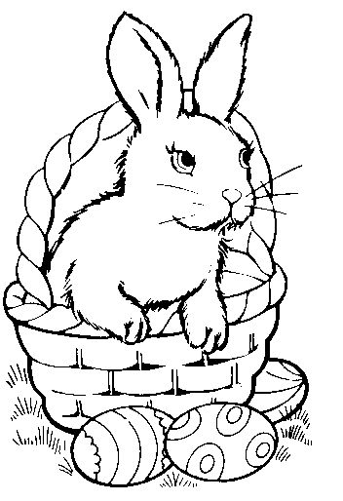](https://www.google.ca/url?sa=i&url=https%3A%2F%2Fclipartart.com%2Fcategories%2Fclipart-easter-egg-basket-black-and-white.html&psig=AOvVaw1joLI3O3uyscBRi3leSDuJ&ust=1586292783600000&source=images&cd=vfe&ved=0CAIQjRxqFwoTCMjQ97vX1OgCFQAAAAAdAAAAABAE)Coccidiosis, whether calves, sheep, pigs, or chickens, is a costly disease. Ensure you have preventative strategies in place and when cases occur treat rapidly for best outcomes. We’re happy to discuss this specifically with you.

***Around the Clinic***

At this time, we remain fully staffed and operational with a few modifications. Human safety is our priority and staff are being careful to honor the extra measures we’ve put in place. While winter is holding on as April begins and about the only thing green around here are the house plants, we are looking forward to feeling the warm and welcome signs of spring. Take care, stay safe, and be healthy! Count your blessings this Easter and feel hopeful!

**Calling Long Distance? Use our toll-free number 1-888-GET VETS (1-888-438-8387)**

**Barb Munholland, DVM, Jackie Dobinson, DVM**

**Associates Cheryl Malin, DVM, Tara Snow, DVM, Mirjam Stigter, DVM, Alicia Laniak, DVM**

**Michelle Hymers, RVT, Helene Neale, RVT, Melissa Whelpton, RVT, Athena Peters, RVT,**

**Andrea Muhlbach, Joanne Halseth, Terra Heier, VPM, Brittany Strandquist, Vanessa Kuziw, VMA, Shelby Boehlke, VTA**

***Check us out online at*** [*www.stettlervetclinic.com*](http://www.stettlervetclinic.com) ***and on Facebook***